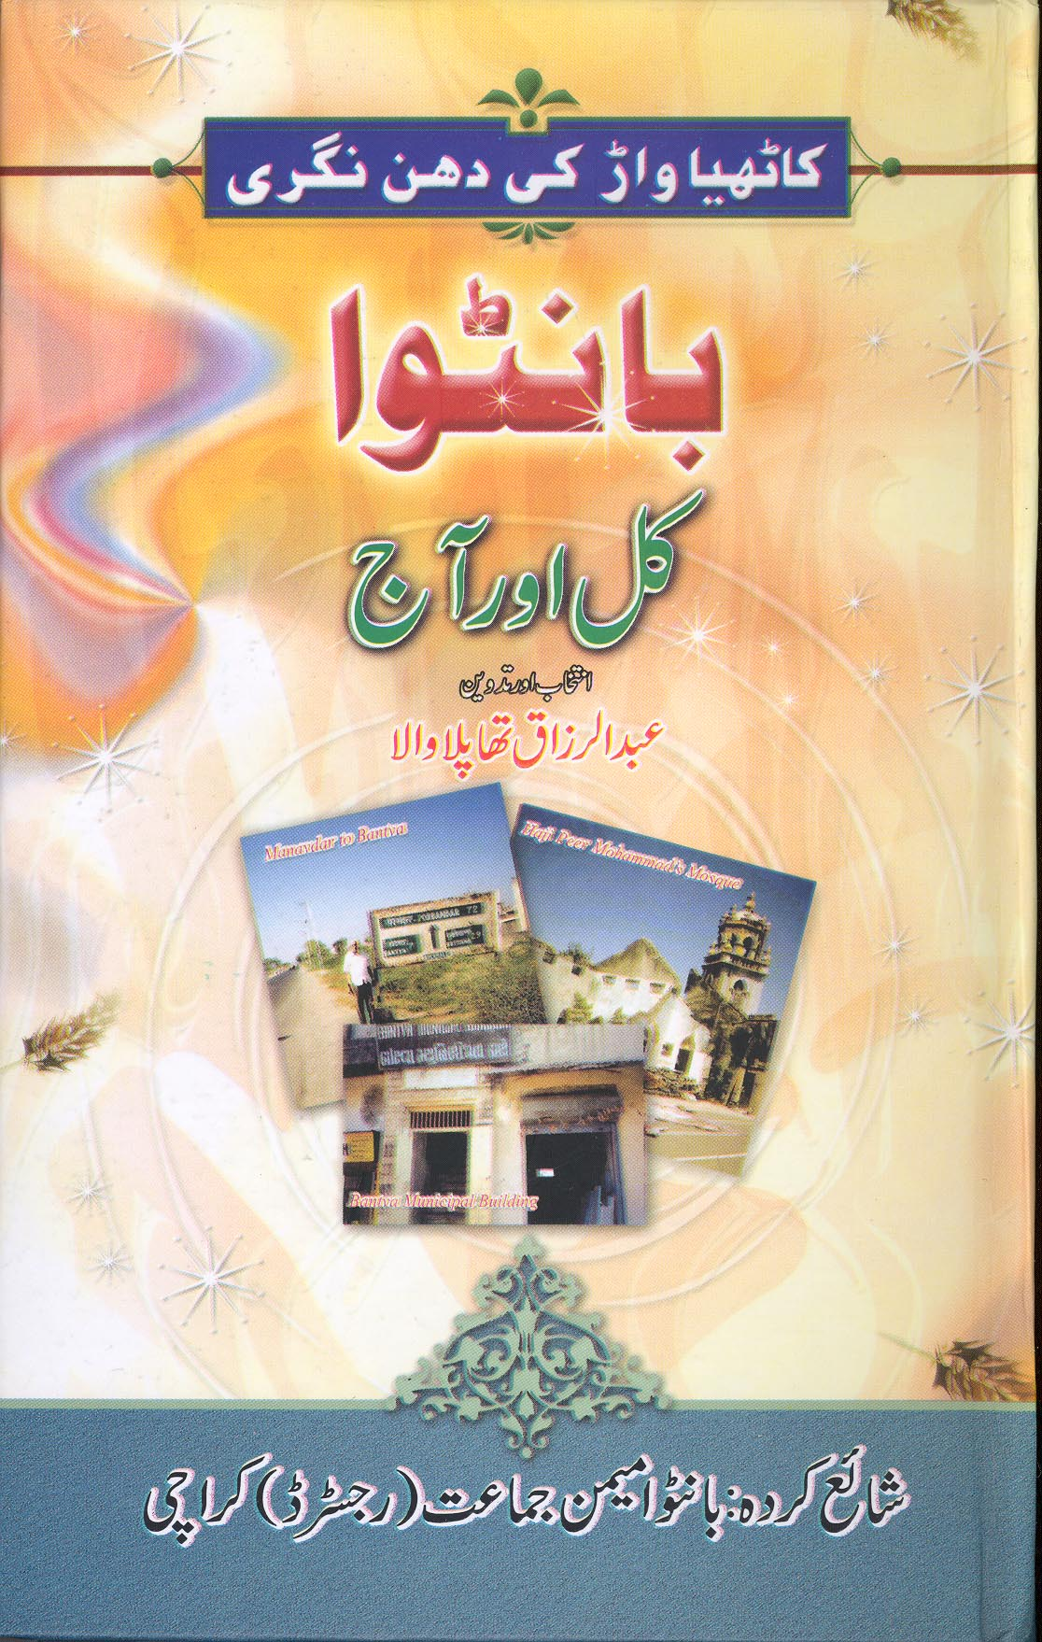

Launching Ceremony of the book
‘Bantva Kul Aur Aaj’

The launching ceremony of the book ‘Bantva Kul Aur Aaj’ by Mr. Abdur Razzaq Thaplawala WAS HELD at Hotel Avari Towers, Karachi on the other days under the chairmanship of Mr. Arif Habib, Past President of Karachi Stock Exchange. The launching ceremony was organized by Bantva Memon Jamat and sponsored by Sea trade Group. The ceremony was attended by well-known dignitaries of the Memon community and others. The speakers including Mr. Arif Habib, Mr. Najeeb Balagamwala, the Author and other emphasized the importance of the book because it conveyed the culture and traditions of the community when they were living in Bantva a Town in Suraster – Gujrat, India having a population of 35 days before partition. The businessman of Bantva are well-known and there were 7 or 8 business firms which had more 100 branches each in various places throughout India, Burma and Sri Lanka. The entire population of Bantva migrated to Pakistan after their houses were attacked by Hindu farmers at night during time the curfew and the presence of Sikh Military main taking round of the streets. The attack was the result of fierce speeches made by Mr. Valabh Bhai Patel and Samardas Gandhi in a public meeting in Junagadh held on 16th November, 1947 after occupation of Junagadh on 9th November, 1947. In their speeches the two Indian leaders’s attacked the Memon’s of Bantva because of very heavy contribution made by them to the press fund of Qaid-e-Azam when the Quaid visit in Bantva in 1944. The speakers told the audience that the book will give an idea of the traditions and culture of the community of Bantva in repartitions days to our youngster because those who were born in Bantva are now quite old and there will be nobody to tell them their personal observations about Bantva after about 10 years.

